This documentation is for gpgmailencrypt 2.x

What is gpgmailencrypt
gpgmailencrypt can encrypt e-mails.
It supports
* PGP/Inline
* PGP/Mime
* SMime

It can be used normally as a script doing everything on command line or in daemon mode, where gpgmailencrypt acts as an encrypting smtp server.
It takes emails and if a encryption key exists for this user it will return the e-mail encrypted to another e-mail server.
The encryption method can be selected per user.

Prerequisites
The following software needs to installed
- python3.x
- gnupg (I recommend version 2)
- openssl

Installation

General
- Copy the file „gpgmailencrypt.py“ into the directory /usr/local/bin and make the file executable via
sudo chmod 755 /usr/local/bin/gpgmailencrypt.py
- Create a default configuration file via
gpgmailencrypt.py -x > ~/gpgmailencrypt.conf
- Copy the configuration file into the directory /etc
sudo cp ~/gpgmailencrypt.conf /etc

Daemon
- Copy the file gpgmailencrypt.init into the directory /etc/init.d via
sudo cp gpgmailencrypt.init /etc/init.d/gpgmailencrypt
- Create a user (gpg-mailencrypt) under which the daemon should run
sudo adduser gpg-mailencrypt
- You can set the user in the file /etc/default/gpgmailencrypt. It should contain
USER="gpg-mailencrypt"
DIR=”/usr/local/bin”

Configuration /etc/gpgmailencrypt.conf

General
[default]
prefered_encryption = pgpinline # valid values are 'pgpinline','pgpmime' or 'smime'
add_header = no # adds a X-GPGMailencrypt header to the mail
domains = # comma separated list of domain names, that should be encrypted, empty is all
spamsubject =***SPAM # Spam recognition string, spam will not be encrypted
output=mail # valid values are 'mail'or 'stdout'
locale=en # DE|EN|ES|FR|IT|NL|PL|PT|RU|SE'

[gpg]
keyhome = /var/lib/gpgmailencrypt/.gnupg # home directory of public gpgkeyring
gpgcommand = /usr/bin/gpg2
allowgpgcomment = yes # allow a comment string in the GPG file

[logging]
log=none # valid values are 'none', 'syslog', 'file' or 'stderr'
file = /tmp/gpgmailencrypt.log
debug = no

[mailserver]
host = 127.0.0.1 #smtp host
port = 25 #smtp port
authenticate = False #user must authenticate
smtpcredential =/etc/gpgmailencrypt.cfg #file that keeps user and password information
#file format 'user=password'

[encryptionmap]
user@domain.com = PGPMIME #PGPMIME|PGPINLINE|SMIME|NONE

[usermap]
#user_nokey@domain.com = user_key@otherdomain.com

[smime]
keyhome = ~/.smime #home directory of S/MIME public key files
opensslcommand = /usr/bin/openssl
defaultcipher = DES3 #DES3|AES128|AES192|AES256
extractkey= no #automatically scan emails and extract smime public keys to 'keyextractdir'
keyextractdir=~/.smime/extract

[smimeuser]
smime.user@domain.com = user.pem[,cipher] #public S/MIME key file [,used cipher, see defaultcipher]

[daemon]
host = 127.0.0.1 #smtp host
port = 10025 #smtp port
smtps = False #use smtps encryption
sslkeyfile = /etc/gpgsmtp.key #the x509 certificate key file
sslcertfile = /etc/gpgsmtp.crt #the x509 certificate cert file
authenticate = False #users must authenticate
smtppasswords = /etc/gpgmailencrypt.pw #file that includes users and passwords
#file format 'user=password'
statistics=1 #how often per day should statistical data be logged (0=none) max is 24

PGP specific configuration
[gpg]
keyhome = /var/lib/gpgmailencrypt/.gnupg # home directory of public gpgkeyring
gpgcommand = /usr/bin/gpg2
allowgpgcomment = yes # allow a comment string in the GPG file

SMIME specific configuration
[smime]
keyhome = ~/.smime #home directory of S/MIME public key files
opensslcommand = /usr/bin/openssl
defaultcipher = DES3 #DES3|AES128|AES192|AES256
extractkey= no #automatically scan emails and extract smime public keys to 'keyextractdir'
keyextractdir=~/.smime/extract

[smimeuser]
smime.user@domain.com = user.pem[,cipher] #public S/MIME key file [,used cipher, see defaultcipher]

Daemon specific configuration
[daemon]
host = 127.0.0.1 #smtp host
port = 10025 #smtp port
smtps = False #use smtps encryption
sslkeyfile = '/etc/gpgsmtp.key' #the x509 certificate key file
sslcertfile = '/etc/gpgsmtp.crt' #the x509 certificate cert file
authenticate = False #users must authenticate
smtppasswords = '/etc/gpgmailencrypt.pw' ;use smtps encryption

The gpgmailencrypt.pw has the following format:
user1=password1
user2=password2
Don't forget to make the file readable only for the gpgmailencrypt user!
The x509 certificate files can be created see:
https://www.e-rave.nl/create-a-self-signed-ssl-key-for-postfi

For the authenticate option see chapter 6.3.

Key Management
The following commands have to be used as the user, that is running gpgmailencrypt. Remember that in daemon mode this user is 'gpg-mailencrypt'. So for daemon mode you first have to change the user
sudo su – gpg-mailencrypt

PGP
Add a PGP key to the public key ring
gpg --import publickey.gpg

SMIME
Smime keys are stored in the directory ~/.smime per default. You have to create it if it does not exist. Each key is stored in a single file in pem-format.
Usually you get the smime.key file in a different format. To convert it use
openssl pkcs7 -print_certs -inform DER -in smime.p7s -out smime.pem

Let's say you get the smime.p7s from agentj@mib.
Instead of 'smime.pem” you should use a unique name for the file and copy it in ~/.smime/
cp smime.pem ~/.smime/agentj@mib.pem

For this user you need also an entry in /etc/gpgmailencrypt.conf
[smimeuser]
agentj@mib = agentj@mib.pem

Integrating gpgmailencrypt in postfix
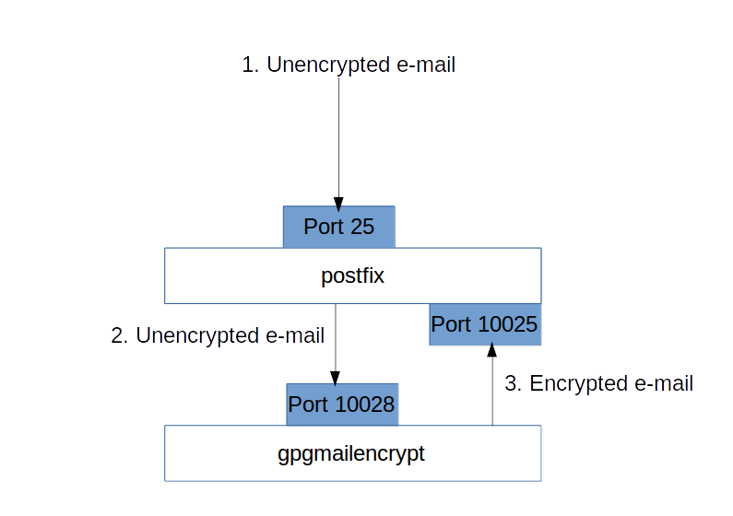
Install and configure gpgmailencrypt as daemon.
/etc/gpgmailencrypt.conf
[mailserver]
host = 127.0.0.1
port = 10025
[daemon]
host = 127.0.0.1
port = 10028

/etc/postfix/main.cf
content_filter=gpgmailencrypt:[127.0.0.1]:10028

/etc/postfix/master.cf
localhost:10025 inet n - n - - smtpd
-o content_filter=
-o mynetworks=127.0.0.0/8
-o receive_override_options=no_unknown_recipient_checks
-o smtpd_recipient_restrictions=permit_mynetworks,reject_unauth_destination
-o smtpd_authorized_xforward_hosts=127.0.0.0/8

gpgmailencrypt unix - - n - 2 smtp
-o smtp_data_done_timeout=1800

Using authentication
For using the authentication add the following to gpgmailencrypt section in master.cf
-o smtp_sasl_auth_enable=yes
-o smtp_sasl_password_maps=hash:/etc/postfix/gpgmailencrypt_passwd

With /etc/postfix/gpgmailencrypt_passwd having the following structure
localhost user:password

Then use the following commands
sudo chmod 640 /etc/postfix/gpgmailencrypt_passwd
sudo postmap /etc/postfix/gpgmailencrypt_passwd

Using smtps
To use the gpgmailencrypt smtps feature with postfix 2.x you need to install stunnel (in Ubuntu the package is called stunnel4)
Create the file /etc/stunnel/gpgmailencrypt.conf
[gpgmailencrypt-smtps]
accept = 10000
client = yes
connect = localhost:10028

And change /etc/default/stunnel4
ENABLED=1
Then start stunnel with
/etc/init.d/stunnel4 start

/etc/postfix/main.cf should be changed to
content_filter=gpgmailencrypt:[127.0.0.1]:10000

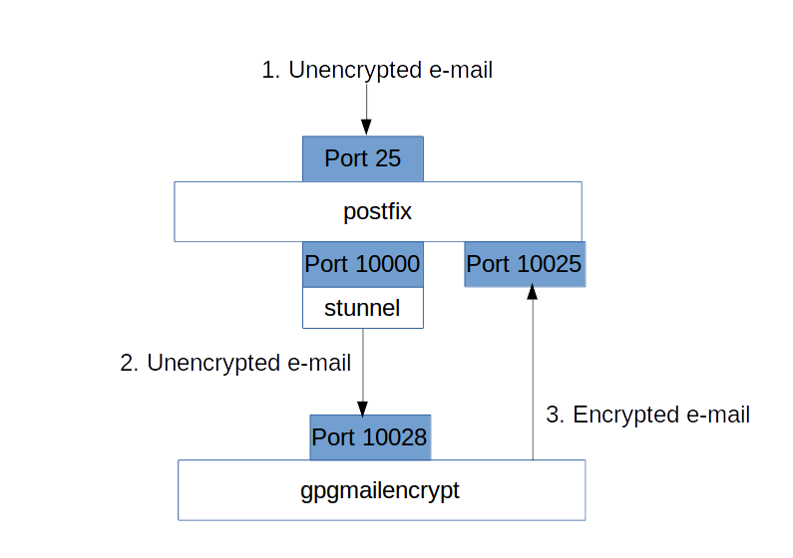

The admin console

The admin user – the hen and egg problem
First you have to create a normal user (which only the admin user can do), then you can give him administration rights.
So for the very first time you have to start the following python program as the user, that runs the gpgmailencrypt daemon. Replace “admin1” and “secreet” with the values you like
#!/usr/bin/python3
import gpgmailencrypt
user=”admin1”
password=”secret”
with gpgmailencrypt.gme() as g:
g.adm_set_user(user,password)

Now the user is created.
Now change the /etc/gpgmailencrypt.conf to the following value
[daemon]
admins=admin1 #comma separated list of admins, that can use the admin console

Now restart the daemon, that's it.

Using the admin console
Start
gme_admin.py localhost 10025
Replace 'localhost' and the port number with the values of your daemon
Now login as an admin user. You will see the following screen
Try to connect to localhost:10025 ...
gpgmailencrypt admin console
============================
User: admin1
Password:
OK
Authentication successful.
Welcome. Enter 'HELP' for a list of commands
> _

The following commands are available
flush | tries to re-send deferred emails
debug true/false | sets the debug mode
deluser | deletes a user  example: 'deluser john'
help | Shows all available commands
quit | leave the console
reload | reloads the configuration file
resetstatistics | sets all statistic values to 0
setuser | adds a new user or changes the password for an existing user  example: 'setuser john johnspassword'
statistics | print statistic information
users | print users

Non-admin users
Users, that don't have the admin privilege can be used to login to the server, when the daemon need authentication, set with
/etc/gpgmailencrypt.conf
[daemon]
authenticate = True #users must authenticate

